Press Release
The Standard Steam Locomotive Company (SSLC)
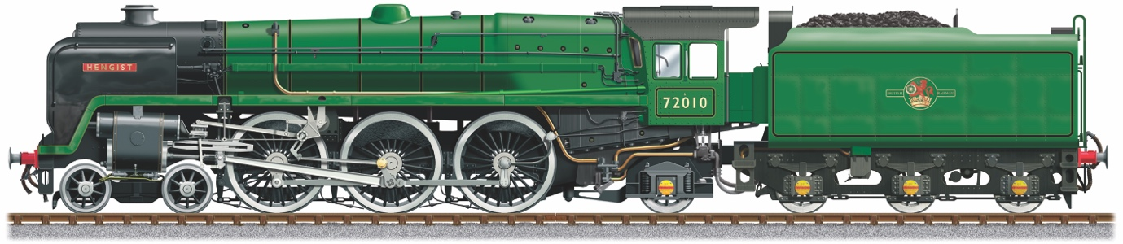
HRH The Duke of Gloucester visits 72010 Hengist Locomotive, being built in Ecclesfield, Sheffield
His Royal Highness, The Duke of Gloucester came to see Sheffield based The Standard Steam Locomotive Company who are the building a Class 6 Pacific Locomotive, named 72010 Hengist.
The Duke was welcomed by the Dame Hilary Chapman, Lord-Lieutenant of South Yorkshire and introduced to Mr Andrew England, MD CTL Seal, the home of the Locomotive.
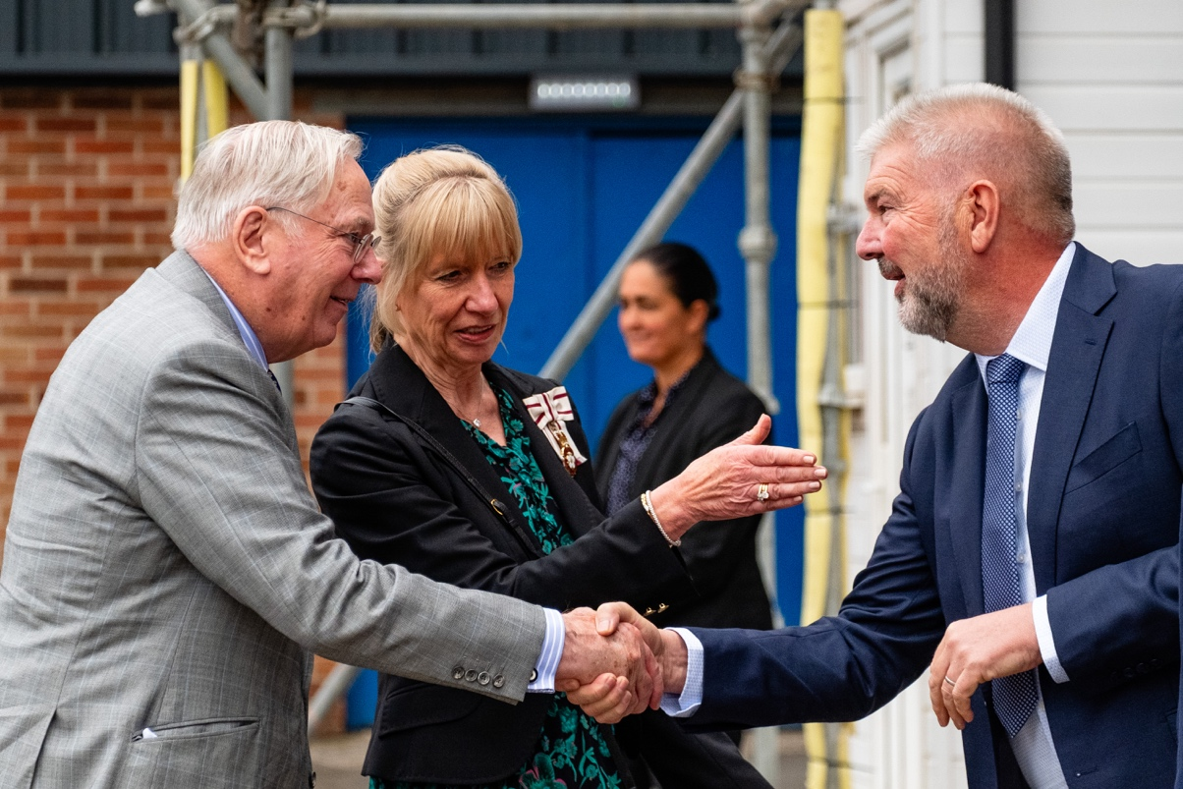
His Royal Highness has already been involved in the restoration and preservation of his namesake, The Duke of Gloucester Locomotive, so a tour of the Hengist works was both interesting and informative and demonstrated how 21st century engineering techniques can be applied to the original 1952 drawings, to make a greener, more efficient Locomotive with greater power.
The Duke met a host of volunteer engineers who are working on the project and enjoyed a presentation showcasing ‘Yorkshire engineering at its best’ from Ian Henderson, Hengist Project Director and a tour of the Locomotive from John Hind, Hengist Technical Director.
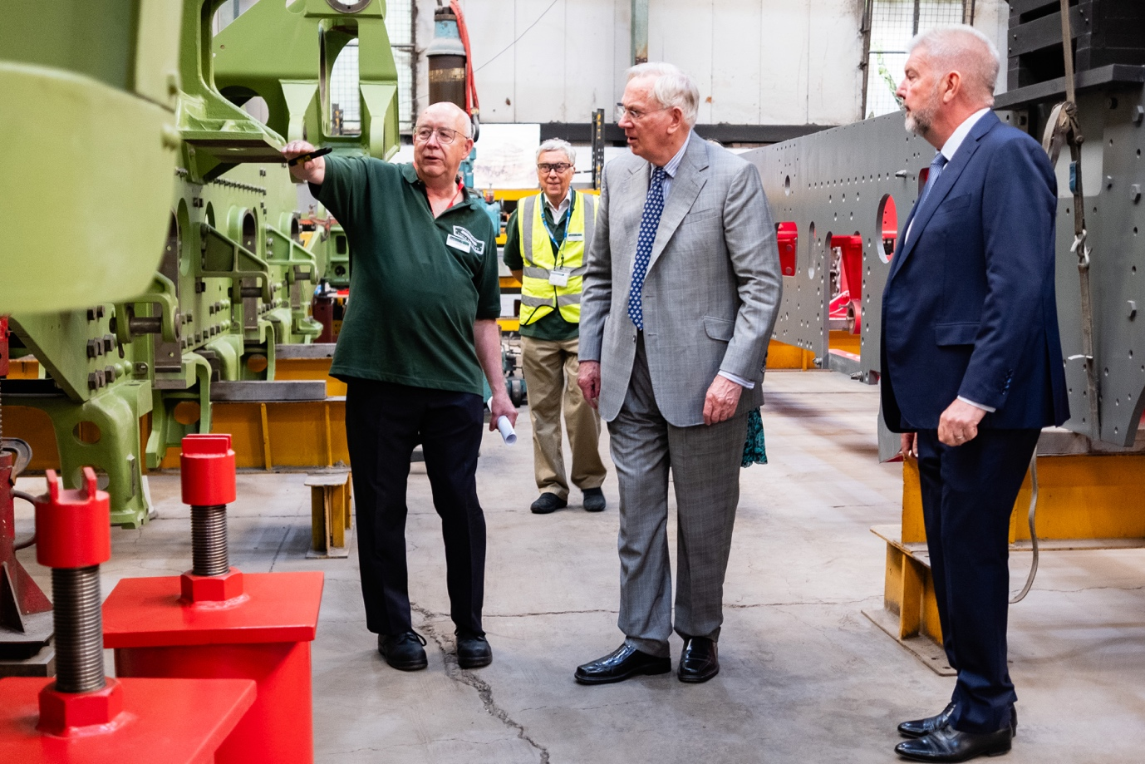
Andy England, MD of CTL Seal, said: "We’re thrilled to have His Royal Highness, The Duke of Gloucester visit Hengist." To have such a distinguished guest supporting what could be the last ever Pacific Steam Locomotive built in the UK is a great honour and we should be proud of our achievement so far. The project is progressing well and we’re looking to raise the next round of funds to complete the boiler and tender. It’s an important part of our heritage, so please help us preserve the future of steam in the UK.”
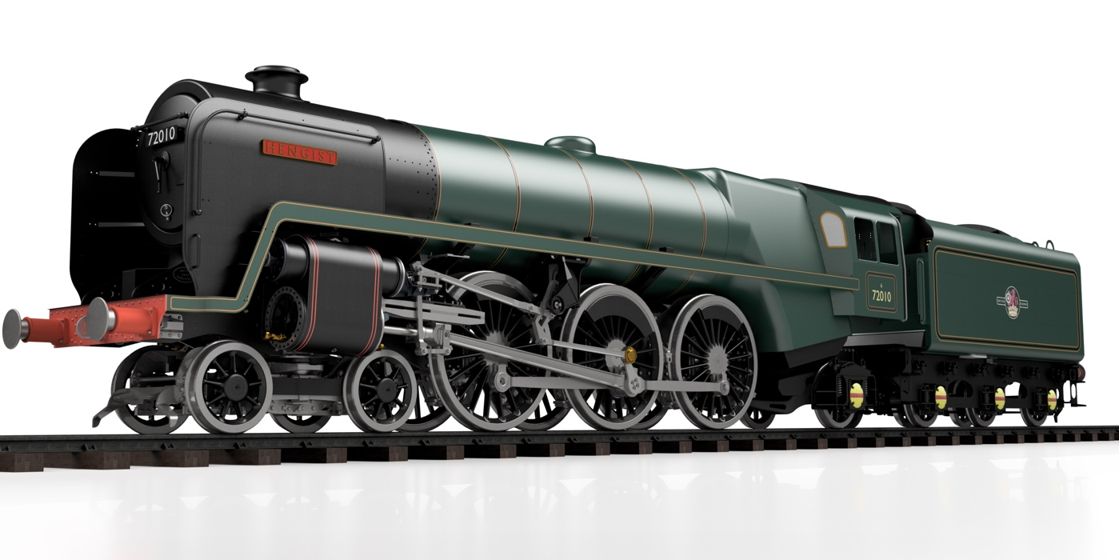
-------------------------------------------------------------------------------------------------------------
Background
Engineering the Future of Steam in Sheffield
Building the lost ‘Clan’ Class 6 Steam Locomotive, called the 72010 Hengist
Originally built in 1952, only 10 of this Iconic British Rail (BR) Locomotive were ever built out of a planned 118. This was due to a steel shortage and the modernisation of the rail network with the introduction of Diesel locomotives.
None of the original locomotives exist now. SSLC are building what would have been the 11th ‘Clan’ Class 6 Locomotive and the 1000th brand new BR locomotive.
Steam Locomotives are part of our national heritage. Everyone likes to see and hear a steam train racing though the countryside. It’s captivating for everyone, albeit for different reasons. A distant memory, a reminder of a past age or simply just an awesome thing to see.
SSLC are preserving the history and heritage for future generations to enjoy.
Made in Sheffield
Leading precision engineering company, Sheffield based CTL Seal, was chosen to build this iconic ‘lost’ locomotive, using a combination of volunteer expert engineers and CTL Seals experienced design and manufacturing team – known as the Sheffield Steam Team!
This project requires a combination of expert craftsmanship combined with 21st century design and technology, to not only re-create the engine in all its aesthetic glory (built to the original design spec), but significantly increase the overall performance and efficiency of the locomotive.

Re-engineering a more sustainable and future-proof Locomotive

SSLC are building a much 'greener & cleaner' locomotive and are also preparing the locomotive for the future, with the long-term development of sustainable steam, The new engine design can be more easily be adapted to take advantage of alternative manufactured fuels that are being developed, using biomass as a key component.
Greener & Cleaner – Better use of fuel
To make Hengist ‘greener’, two key changes are going to be made. Firstly, increase
boiler pressure by 25 psi from 225 psi to 250 psi, which extracts more energy from
the fuel and secondly, design a 21st century exhaust system which improves
combustion and reduces backpressure on the cylinders. Computer simulations
suggest that these two improvements help Hengist reduce harmful greenhouse gas
emissions, by up to 10.5%.

More Powerful - Essential for steam operation on today's railway
The higher boiler pressure and the improved exhaust system also mean that Hengist is 22% more powerful. The benefit is that it can pull more coaches or run faster uphill, giving greater operational flexibility for running on the mainline.
More Efficient - More effective use of steam
When new, the original Clans had one of the lowest fuel consumptions of any British
Standard Steam Locomotive. Hengist is expected to improve on this. As well as the
improved exhaust system and higher boiler pressure other improvements are going
to be made to the pistons and valves to reduce steam leakage and reduce wear,
through improved materials and lubrication.
Another high-profile engineering project Sheffield can be proud of
SSLC is a registered charity and need to raise £4M to re-create this iconic locomotive in all its glory. Completion date for the Locomotive is 2029 and after that you will see it running on heritage and eventually mainline rail networks.

---------------------------------------------------------------------------------------------------------
Steven Cooper, Hengist Fundraiser & Marketing. Contact 07879 602995
For more information, please visit
www.72010-hengist.co.uk
To give a one-off donation, please go to our Go Fund Me Page
www.gofundme.com/hengist
The Standard Steam Locomotive Company Ltd
C/O CTL Seal, Butterthwaite Lane, Ecclesfield, Sheffield S35 9WA
Charity No.1062 320 Co.Reg. 3192 444

